Lab - Investigate BIOS or UEFI Settings

Introduction
In this lab, you will boot the computer, explore the firmware setup utility program, and change the boot order sequence.

Recommended Equipment
- Computer with or without operating system
- Motherboard manual

Instructions

Enter BIOS or UEFI.

Power on the computer.
      - Plug the power supply cable into an AC wall outlet.
      - If there is a power switch on the power supply, set the switch to “1” or “on”.
      - Turn on the computer with the power button on the front panel.
Note: If the computer beeps more than once, or if the power does not come on, notify your instructor.

Enter the firmware setup program.
During POST, press the firmware setup key or key combination. The firmware setup utility program screen will appear.

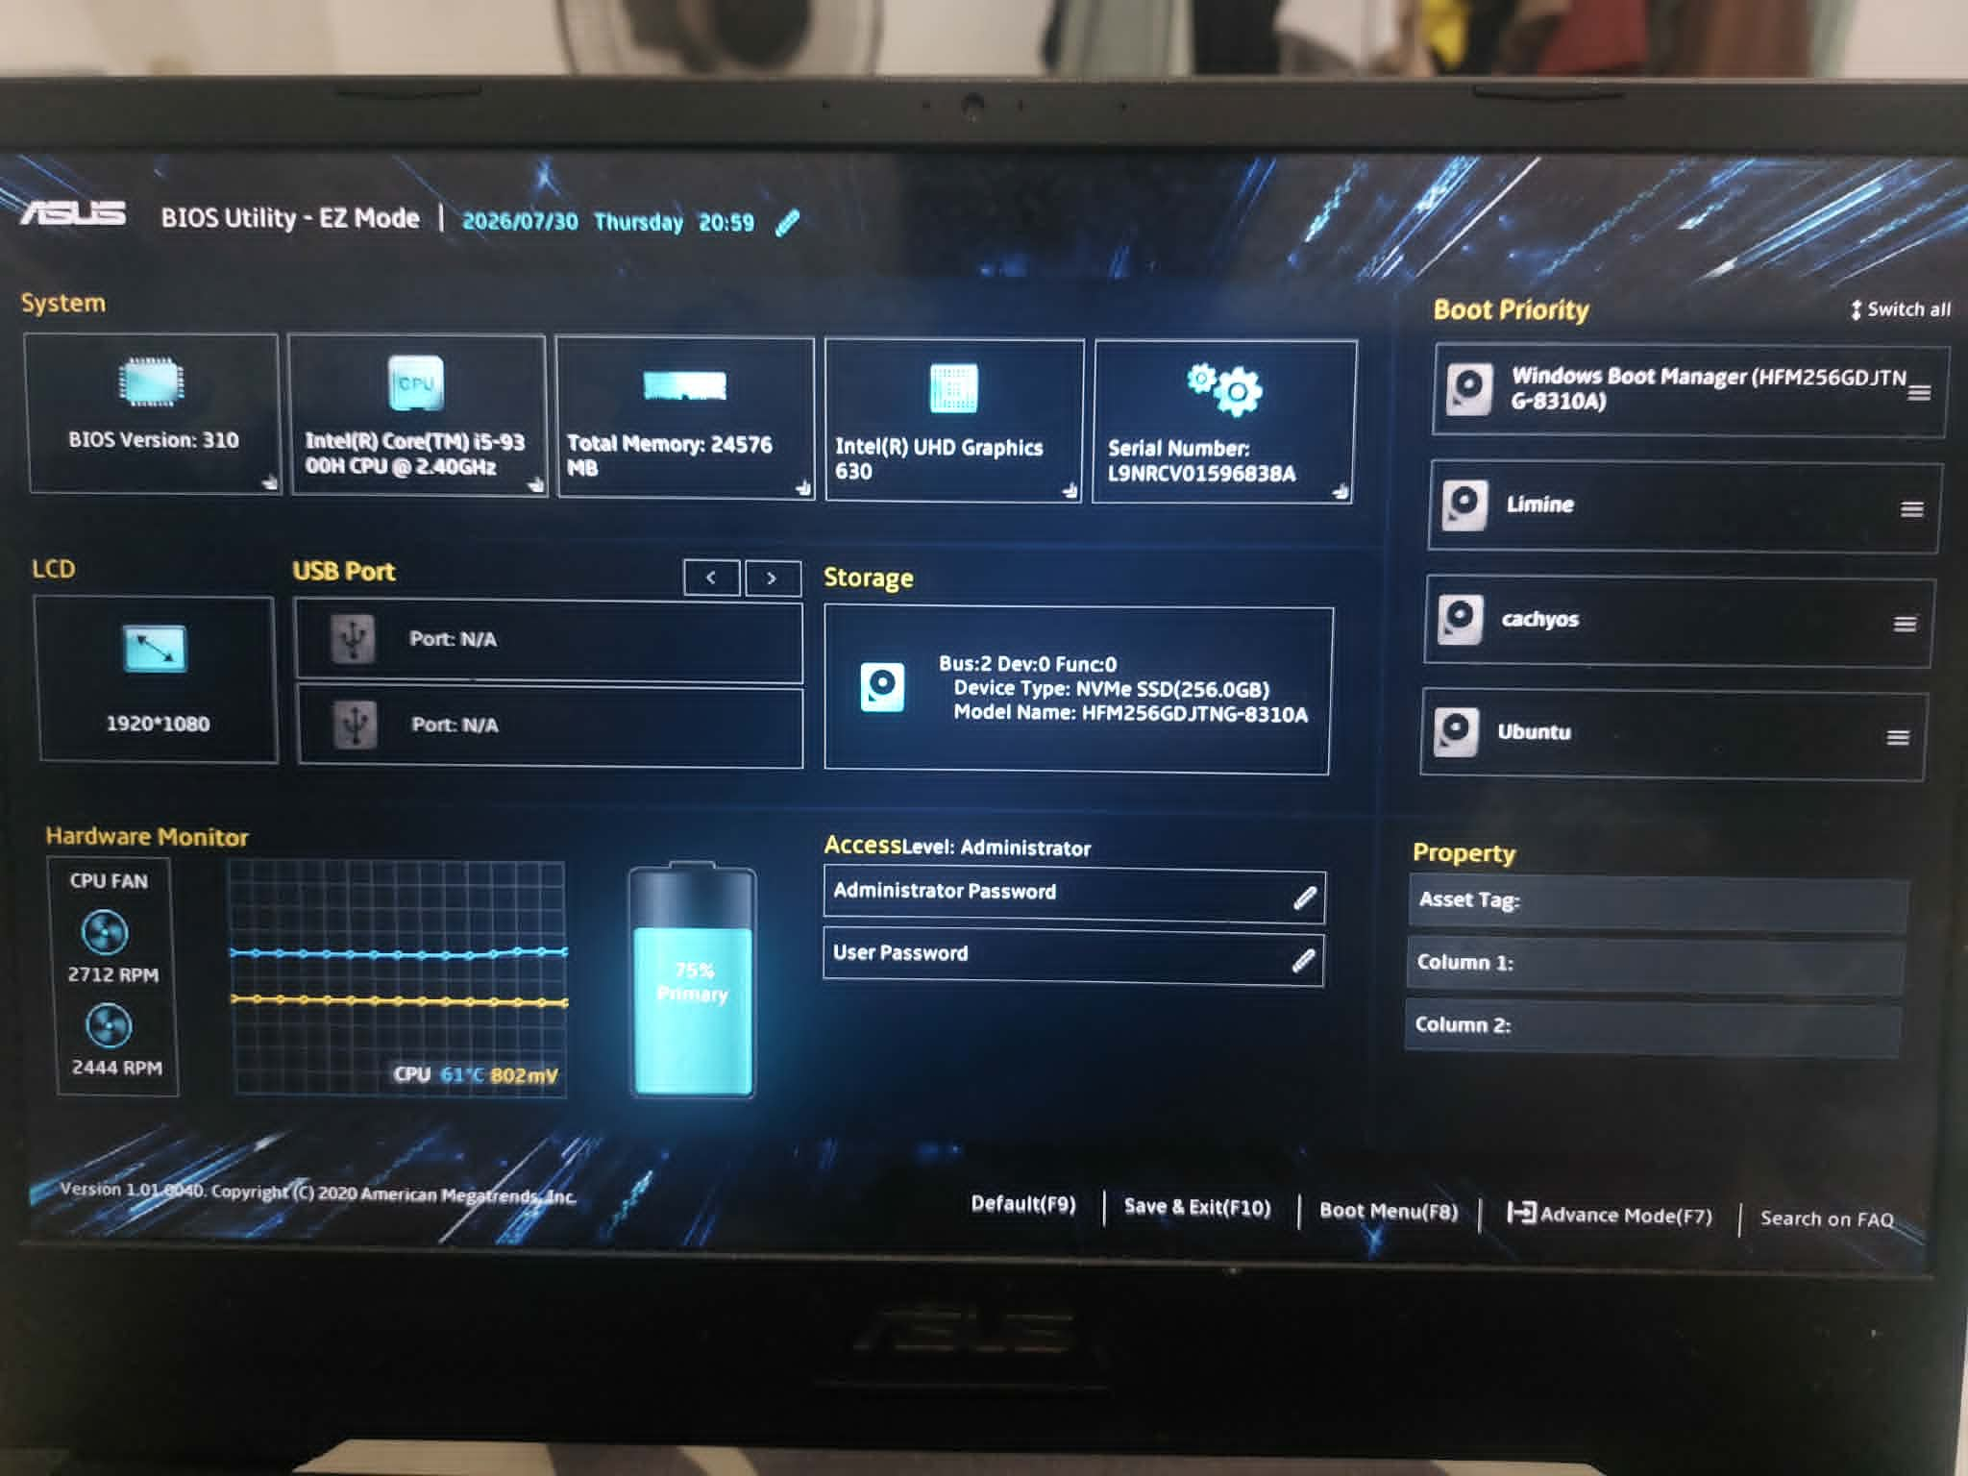

Questions:
What is the key or combination of keys used to enter the firmware setup utility program?
- In this case, the key I used to enter the firmware setup utility program was F2.
Who manufactures the BIOS or UEFI system for your computer?
- American Megatrends Inc. manufactures the BIOS system for my laptop.
What is the BIOS or UEFI version?
- The BIOS version in this case is 1.01.004D.

Explore the Settings.

List the main menu options.

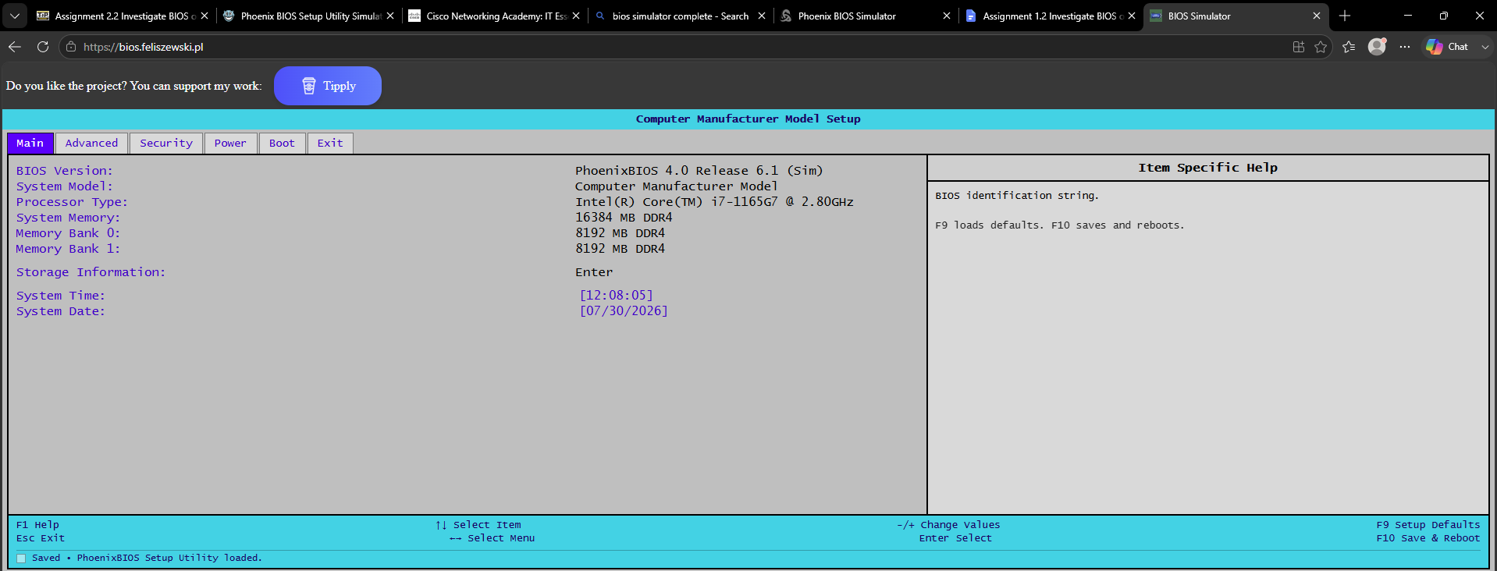

Question:
List the main menu options and describe what is monitored in each menu?
- BIOS Version - It displays the current version of the BIOS firmware installed
- System Model - It shows the computer or motherboard model name/number
- Processor Type - It displays information about the CPU, including its model and speed.
- System Memory - It shows the total amount of RAM installed in the computer
- Memory Bank 0 - It shows details of the RAM module installed in the first slot.
- Memory Bank 1 - It shows details of the RAM module installed in the second slot.
- Storage Information - It lists the connected storage devices such as HDDs and SSDs and their specifications.
- System Time - It displays the current clock time used by the computer.
- System Date - It displays the current date used by the computer.

Find the security settings.
Navigate through each screen to find the security settings.
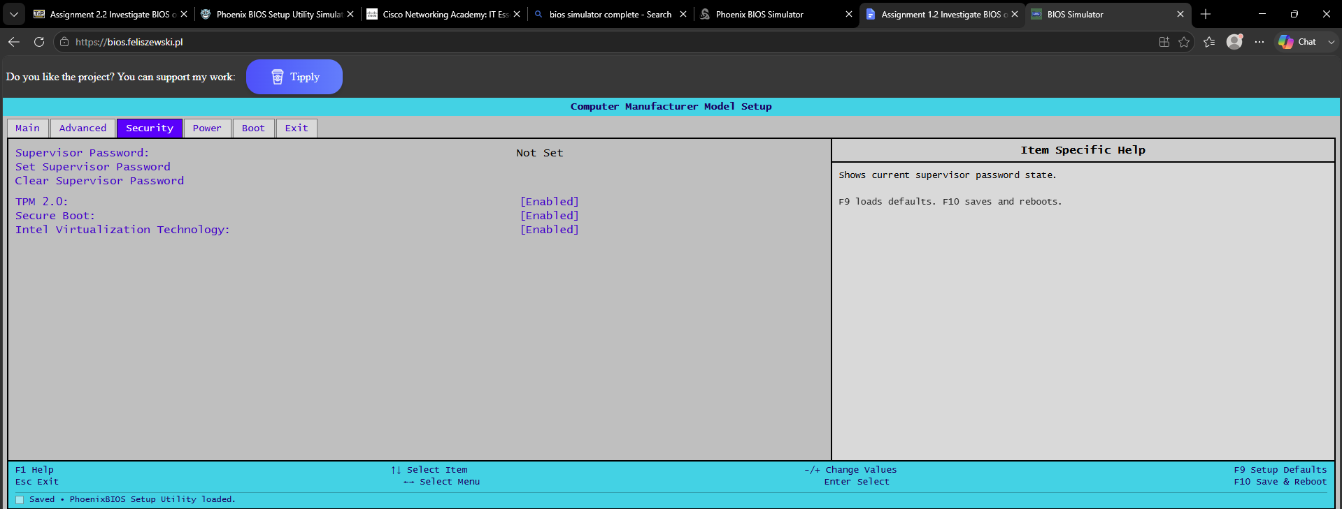

Question:
What security settings and features are available?
- The available security settings and features include the supervisor password, where you can set or clear your password. The TPM where you can enable or disable your TPM device which is a dedicated security chip. Secure boot which is a UEFI security standard that ensures your PC only boots with trusted softwares, which you can also enable or disable. And it also has Intel Virtualization Technology that lets your computer run multiple operating systems simultaneously, which you can also enable or disable.

Find the CPU settings.
Navigate through each screen to find the CPU settings.

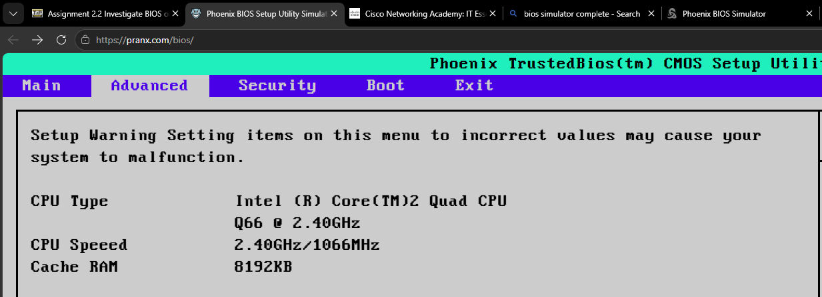

Questions:
What is the CPU speed?
- The CPU speed contained in this BIOS simulator is 2.40GHz,1066MHz
What other information is listed for the CPU?
- Other information listed includes the CPU type which shows detailed information about your CPU model, and the CPU’s Cache RAM which contains 8192 KB of RAM.

Find the RAM settings.
Navigate through each screen to find the RAM settings.
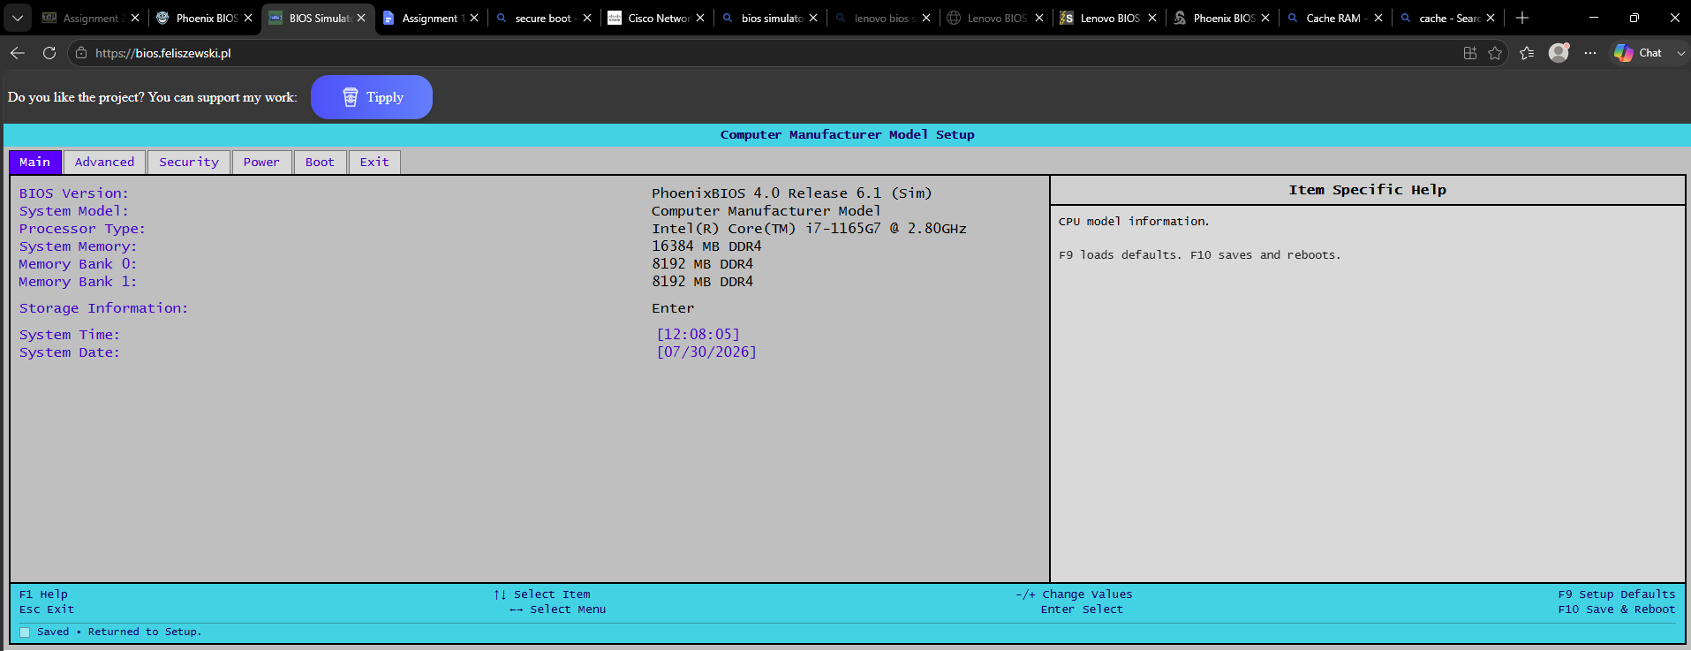

Questions:
What is the RAM speed?
- The RAM speed indicated in this computer is 4400 MT/s
What other information is listed for the RAM?
- Other information listed for the RAM is the type of RAM the computer uses. In this simulator, it uses 8192 MB DDR4 RAM.

Find the hard drive settings.
Navigate through each screen to find the hard drive settings.

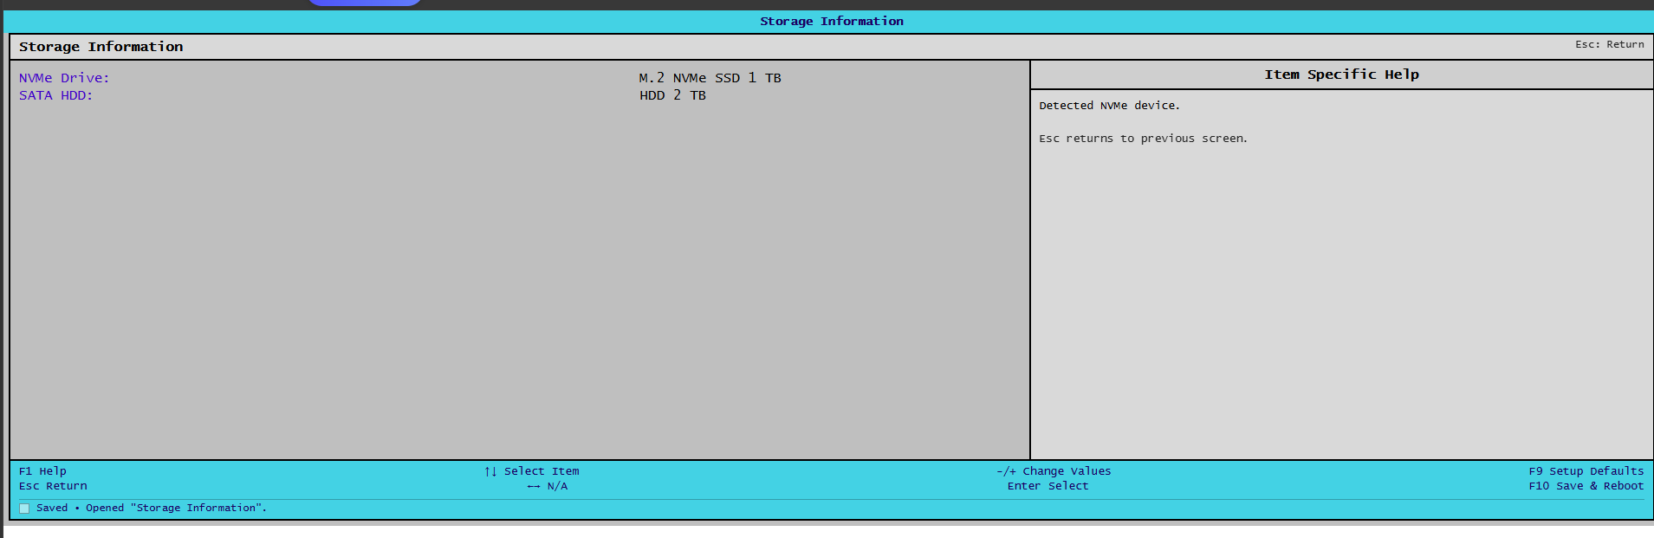

Questions:
What information is listed for the hard drive?
- In this BIOS Simulator, information about the type of hard drive is indicated. It shows that it has a 1 TB NVMe SSD and a 2 TB HDD. If this is a real BIOS setup, more information should be included about their specifications.

Find the boot order sequence.
Navigate through each screen to find the boot order sequence.
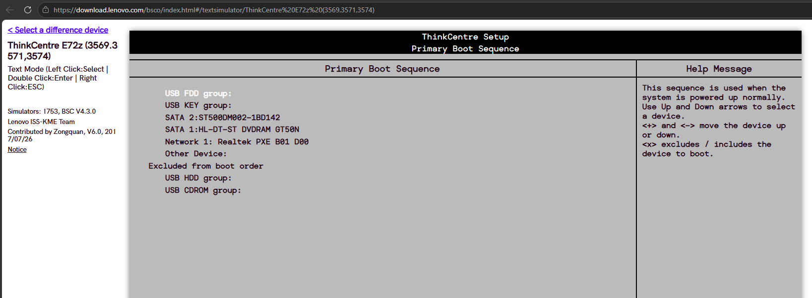

Questions:
What is the first boot device in the boot order sequence?
- The first boot device is USB FDD, which means the computer checks this device first when it starts up to see if it can boot from it.
How many additional devices can be assigned in the boot order sequence?
- There are 7 devices listed in the boot order. Since USB FDD is the first one, there are 6 more devices after it that the computer can check if needed.

Set the device boot order settings.

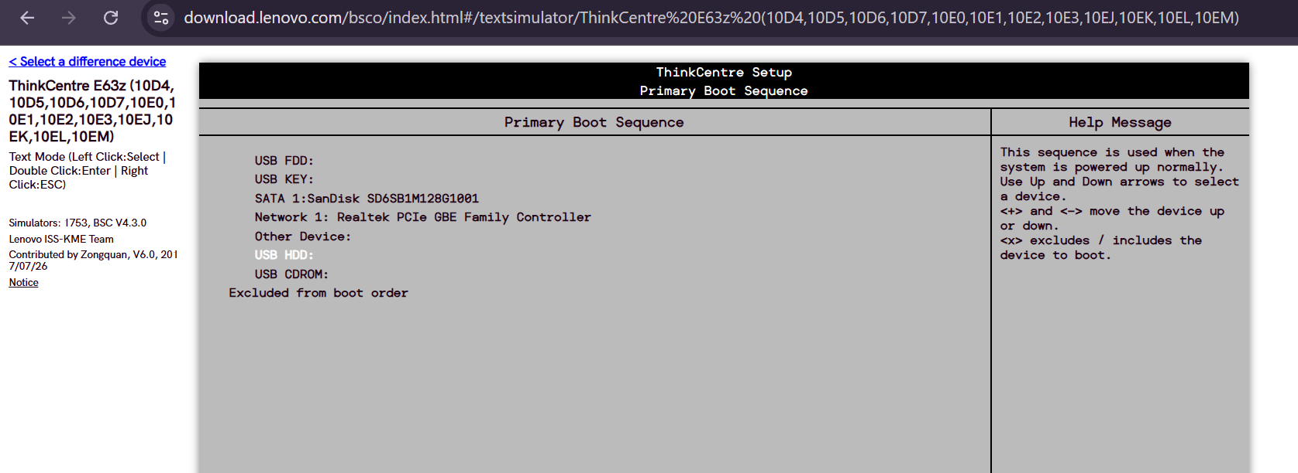
      - Ensure that the first boot order device is the optical drive.
      - Ensure that the second boot order device is the hard disk drive.
- (Sir, I couldn’t change the boot orders. No matter how many BIOS simulators I tried, they don’t work. But I now understand what happens when we change the boot order.)

Questions:
Why would you change the first boot device to the optical drive?
- You would change the first boot device to the optical drive if you want your computer to start from a CD or DVD, such as when installing an operating system or using a recovery disc.
What happens when the computer boots and the optical drive does not contain bootable media?
- If there is no bootable CD or DVD in the optical drive, the computer will skip it and try to boot from the hard disk drive, which is the second boot device.

Find the power management setup or ACPI screen.
Navigate through each screen to find the power management setup screen, or ACPI screen.
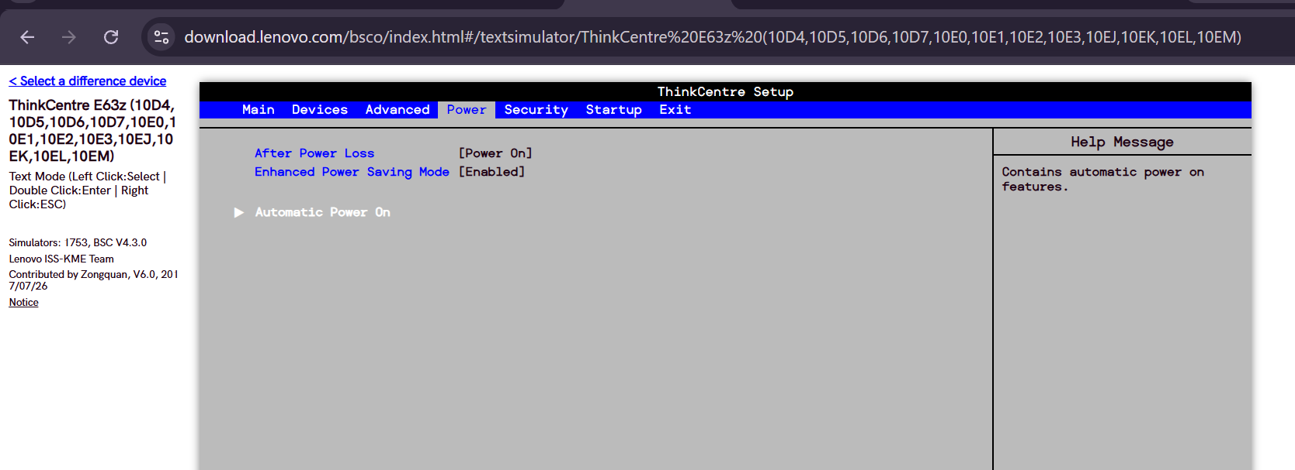
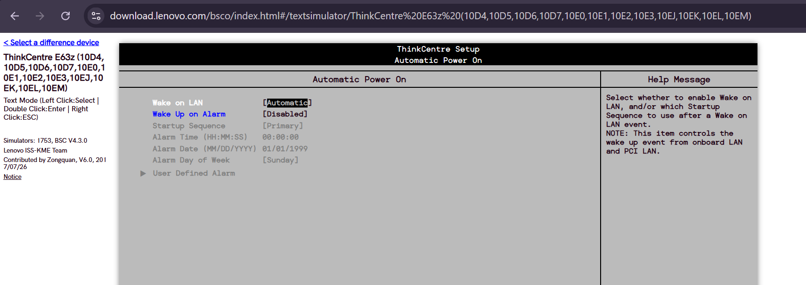

Question:
What power management settings are available?
- After Power Loss – Sets what the computer does after power is restored
- Enhanced Power Saving Mode – Enables or disables additional power-saving features to reduce power consumption.
- Automatic Power On – Lets you configure the computer to turn on automatically at a scheduled time or under certain conditions.

Find the PnP settings.
Navigate through each screen to find the PnP settings.
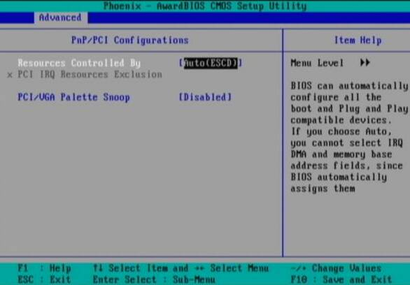

Question:
What PnP settings are available?
- Resources Controlled By
- PCI IRQ Resources Exclusion
- PCI/VGA Palette Snoop

Find the splash screen settings.
Navigate through each screen to find the splash screen settings.
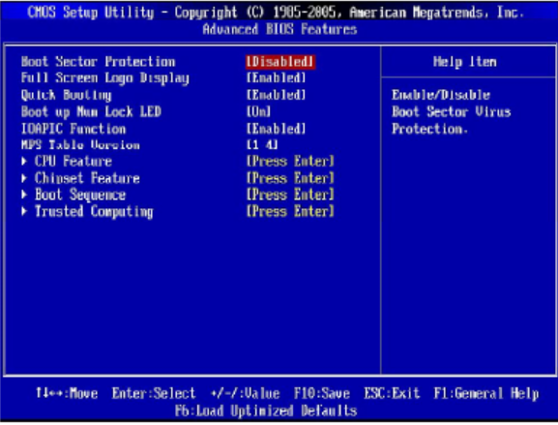

Question:
What splash screen settings are available?
- The only available splash screen setting in this case is Full Screen Logo Display. It can be set to Enabled or Disabled to show or hide the manufacturer's startup logo during boot.

Save and exit the setup utility program.
Save the new BIOS/UEFI settings and exit the setup utility program. The computer should restart automatically.
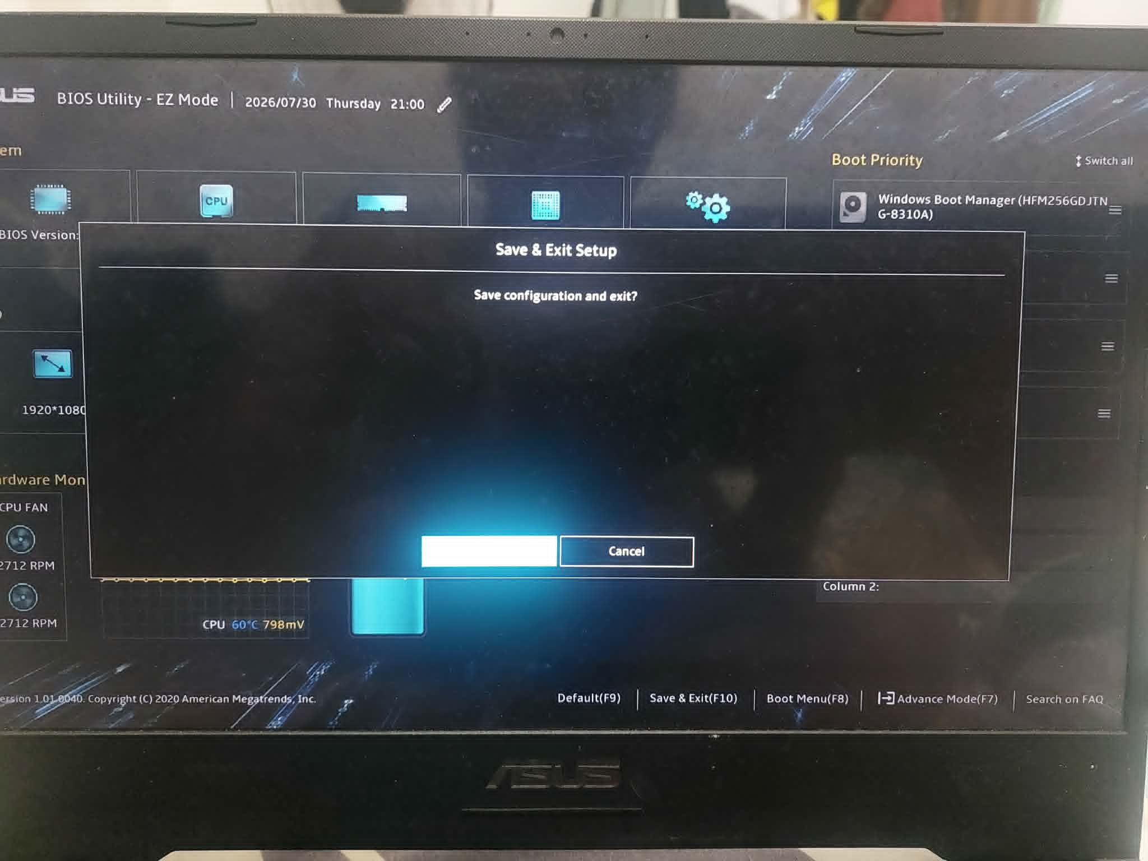
Note: An error message stating that an OS cannot be found (or a similar error) will appear on the screen after the computer boots. An operating system must now be installed to prevent this error. It is safe to turn off the computer at this time.
This lab is complete. Please have the instructor verify your work.
End of Document

